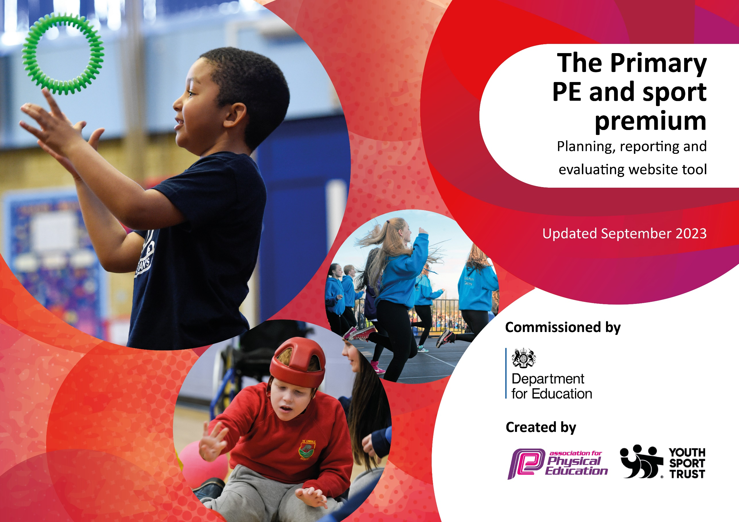

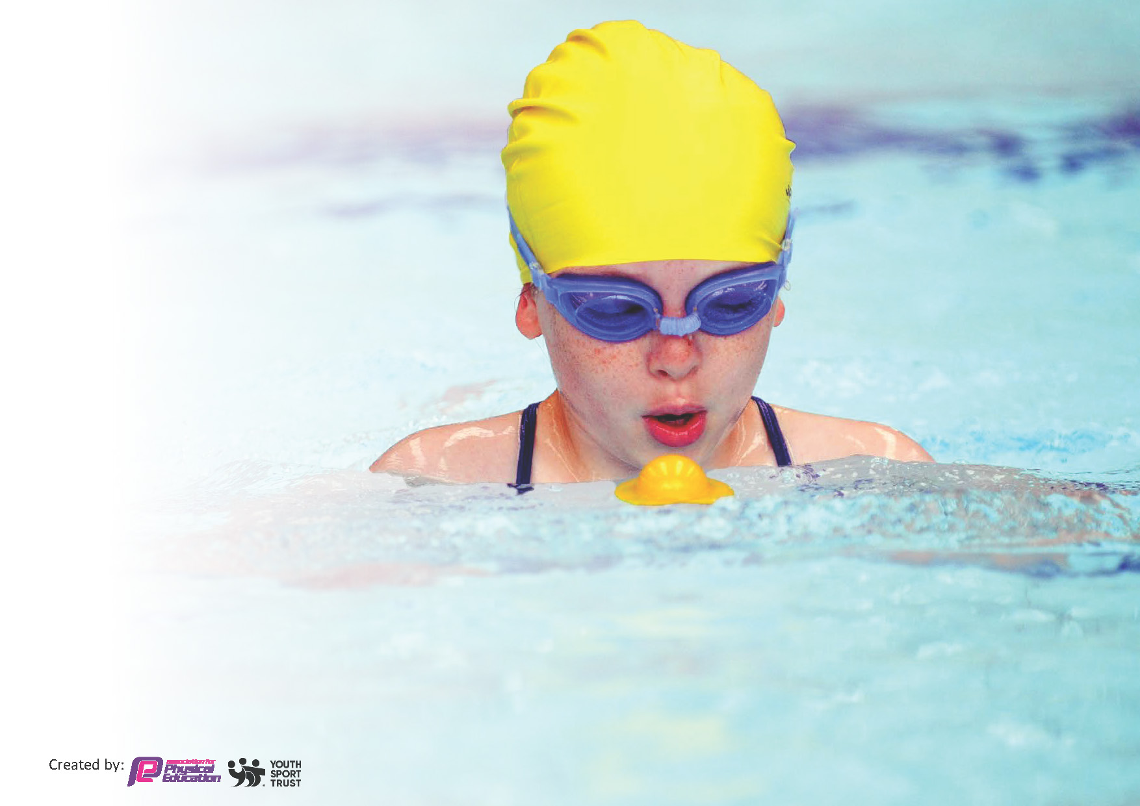
This template can be used for multiple purposes:
by:
- It enables schools to effectively plan their use of the Primary PE and sport premium
- It helps schools to meet the requirements (as set out in guidance) to publish information on their Primary PE and sport premium
- It will be an effective document to support Ofsted inspections enabling schools to evidence progress in Physical Education (PE) and evidence swimming attainment, which forms part of the PE National Curriculum. We would recommend schools consider
the Intent, Implementation and Impact of any spend, as examined within the Education Inspection Framework.

It is important that your grant is used effectively and based on school need.

Schools must use the funding to make additional and sustainable
improvements to the quality of the PE, School Sport and Physical Activity (PESSPA)
they offer. This means that you should use the Primary PE and sport premium to:

- Build capacity and capability within the school to ensure that improvements made now will benefit pupils joining the school in future years
- Develop or add to the PESSPA activities that your school already offers.

The Primary PE and sport premium should not be used to fund capital spend projects; the school’s core budget should fund these. Further detail on capital expenditure can be found in the updated Primary PE and sport premium guidance.

The Primary PE and sport premium guidance, outlines 5 key priorities that funding should be used towards. It is not
necessary that spending has to meet all the key priorities, you should select the priorities that you aim to use any funding towards.

Although completing this template is not a requirement for schools, schools are required to publish details of how they spend this funding. Schools must also outline what the impact this funding has had on pupils’ PE and sport participation and attainment and how any spending will be sustainable in the future. All funding must be spent by 31st July 2024.

The Department for Education has worked closely with the Association for Physical Education (afPE) and the Youth Sport Trust (YST) to develop this template and encourages schools to use it. This template is an effective way of meeting the reporting requirements of the Primary PE and sport premium.
Review of last year’s spend and key achievements (2022/2023)

We recommend you start by reflecting on the impact of current provision and reviewing your previous spend.
Total amount of funding for 2022-2023 was: £16,840

Activity/Action | Impact | Comments
Lunchtime Play Leaders £3200 / equipment and resources | Skill Development: Our investments in coaching and resources enhanced the skills and competence of both students and staff, fostering a culture of physical activity that lasts beyond this academic year.  The Real PE curriculum and updated resources provide a structured approach to PE, ensuring sustainability by enabling teachers to consistently deliver high-quality lessons and knowing the next steps in skill development.  Initiatives like sports day and after-school clubs promoted a sense of community, enjoyment of sport, a culture of sportsmanship and encourage involvement in sports and physical activities beyond the school premises.  The artificial grass and physical equipment improved the quality and longevity of our facilities, supporting sustainability.  Conclusion:  We firmly believe that our allocation of the Sports Premium budget for the academic year 2022-2023 has led to sustainable improvements in our PE provision. These investments aim not only to benefit the current generation of students but also to leave a lasting legacy of physical health and well-being in our school community.
Development of Football Zones £3840
REAL PE £834.00
Specialist Sports Coach to train staff £7500
Buy into Scootfit, Sports for champions Athlete and Yorkshire Sports Foundation £1000
Sports Day £200
Multi skills events with other schools £250
Total Amount Spent: £16,824

Key priorities and Planning
This planning template will allow schools to accurately plan their spending.

Key Indicators:
- Increased confidence, knowledge and skills of all staff in teaching PE and sport
- The engagement of all pupils in regular physical activity
- The profile of PE and sport is raised across the school as a tool for whole-school improvement
- Broader experience of a range of sports and activities offered to all pupils
- Increased participation in competitive sport
Action – what are you planning to do | Who does this action impact? | Key indicator to meet | Impacts and how sustainability will be achieved? | Cost linked to the action
Specialist Sports Coach up until Christmas to support implementation of new PE scheme | Pupils benefit from improved PE teaching, also supporting their overall well-being.  Teachers gain valuable insights and skills from the sports coach, enhancing their ability to deliver high-quality PE lessons.  Parents can witness the positive effects of their children's experience of PE.  The school community as a whole benefits as the increased quality of PE teaching supports a holistic approach to pupil well-being and development. | Increased confidence, knowledge and skills of all staff in teaching PE and sport.  Broader experience of a range of sports and activities offered to all pupils. | Learning walks/drop ins demonstrate that staff are delivering high quality PE lessons, with increased levels of pupil participation.  Lessons are more focused on teaching points and in-lesson assessment followed by teacher intervention/scaffolding. | £2310.00  (£165.00) per week  x14 weeks
Implement a new PE scheme across the whole school- Purchased into GetSet4PE January 2024. | Pupils benefit from an enriched PE curriculum, promoting their physical health and engagement in physical activities.  Teachers gain access to a comprehensive planning tool, supporting them in delivering well-structured and effective PE lessons and ensuring progress and skill development over time.  Parents can appreciate the positive impact on their children's physical education experiences. | Increased confidence, knowledge and skills of all staff in teaching PE and sport | Staff report feeling more confident in teaching PE. They feel lessons are higher quality and progression in skills in stronger than in previous years.  They feel lessons are more engaging and pupil enjoyment and participation are higher.  Staff report that the scheme has helped them to differentiate/adapt teaching more effectively to differing abilities.  At the end of the 23-24 academic year, 80.6% of children achieved expected in physical development at the end of EYFS (gross and fine motor)  100% of the current year 2 children were working at ‘at’ or ‘just at’ at the Y1 expectations at the end of Y1. | £340 (year)- based on GET Set4PE
Development of KS1 playground to maximize opportunities for physical activity outside of PE lessons | Pupils benefit from enhanced physical health and well-being, as they engage in active play that promotes motor skills, coordination, and overall fitness and core strength. Additionally, teachers observe improved focus in the classroom, as pupils release excess energy through outdoor play. Parents witness the positive effects of the playground on their children's physical development and overall well-being. | Broader experience of a range of sports and activities offered to all pupils | Increased numbers of children are accessing physical provision through the day. Children are confident and taking risks with their physical abilities. | Amount £5,500
Partnership with Superstar Sports to provide specialist-sports after school clubs. | Pupils benefit from exposure to a wider-range of sports, fostering a range of skills and interests beyond the regular curriculum.  Parents appreciate the opportunities for their children to explore playing different sports and may be inspired to access other out-of-school clubs for their children.  The wider school community benefits from an after-school program, contributing to pupil well-being and a positive school culture which promotes healthy and active lifestyles among pupils. | Increased participation in competitive sport | Uptake for after school clubs was high, so much so that at times we had two running in one week.  Parents have been very positive about this and have requested that we continue this, valuing the range of opportunities and variety in activity type. | Spring 2 Gymnastics after school club- £200 (5 weeks @ £40.00 per session)  Summer 1 Ninja Warrior after school club- £240 (6 weeks @ £40.00 per session)  Football (5 weeks @ 40.00 per session) £200  Summer 2-  Football (7 weeks @ £40 per session) 280.00  Total spent on after-school club provisions-  £920
Development of a self-access ‘Activity Shed’ in KS1 to enrich and diversify the range of physical activities available to pupils throughout the school day, extending beyond structured PE lessons. Incluidng CPD for staff. | This will enrich and diversify the range of physical activities available to pupils throughout the school day, extending beyond structured PE lessons. This will empower children to engage in unstructured physical activity for pleasure, fostering independence, creativity, and social interaction. By providing a variety of resources and equipment, we will encourage active lifestyles and promote physical development, which is essential for overall well-being. | Broader experience of a range of sports and activities offered to all pupils | This has had an impact on both physical development and overall engagement during playtimes. By providing a diverse range of equipment and resources, we have observed increased participation in physical activities. Children are empowered to choose and initiate their own play. Staff members have reported positive changes in pupils' behaviour, with increased focus and readiness to learn following active playtimes. | £3000
Sports Day | Pupils benefit from the opportunity to engage in friendly competition, promoting teamwork, sportsmanship, and physical fitness.  Teachers play a pivotal role in organising and facilitating the event, fostering leadership skills and school spirit among students.  Parents experience pride and support as they witness their children participate and excel in various athletic activities. Additionally, the wider community may be impacted positively as they witness the school's commitment to promoting health, fitness, and community engagement through sports and promotes a positive school culture centered around physical activity and teamwork. | The profile of PE and sport is raised across the school as a tool for whole-school improvement  Broader experience of a range of sports and activities offered to all pupils  Increased participation in competitive sport | We have observed that Sports Day has had a significant impact on pupils and the school community. Pupils have shown a heightened sense of excitement and pride as they participate in various events, showcasing their physical abilities and talents. Many students have expressed feelings of achievement, which has boosted their self-confidence and enjoyment of sport and physical activity.  From a school perspective, Sports Day has reinforced the importance of physical activity and healthy lifestyles, encouraging all students to engage in fitness and well-being. | £300
Staff CPD  1.PE subject leader to attend Yorkshire Sport PE Conference | This will impact on the overall quality and delivery of physical education within the school. By engaging with a network of professionals and gaining insights into the latest trends, strategies, and best practices in PE, the subject leader will be better equipped to enhance the PE curriculum and provide high-quality experiences for all pupils.  This conference will offer opportunities for professional development, including workshops and discussions led by experts, which can directly inform teaching methods and improve the effectiveness of PE lessons. The knowledge and resources acquired can be shared with colleagues through in-school training sessions, ensuring that the entire staff benefits from the insights gained. | The profile of PE and sport is raised across the school as a tool for whole-school improvement  Increased confidence, knowledge and skills of all staff in teaching PE and sport | Learning walks/drop ins demonstrate that staff are delivering high quality PE lessons, with increased levels of pupil participation.  Evidence in assessments:  At the end of the 23-24 academic year, 80.6% of children achieved expected in physical development at the end of EYFS (gross and fine motor)  100% of the current year 2 children were working at ‘at’ or ‘just at’ at the Y1 expectations at the end of Y1. | 1.Yorkshire Sport PE conference- £75.00  £216 (Cover from Provide Education for sports leader to attend)
Lunchtime play leaders to deliver active lunchtimes, ensuring there is a range of sports provision and team building activities. | This will create an active playground environment that promotes physical activity and teamwork among pupils. By providing a structured approach to lunchtime activities, play leaders will facilitate a variety of sports and team-building exercises, helping to enhance pupils' physical skills. As a result, we anticipate an increase in overall physical activity levels, improved fitness, and enhanced well-being among pupils. | Broader experience of a range of sports and activities offered to all pupils  The engagement of all pupils in regular physical activity - the Chief Medical Officer guidelines recommend that all children and young people aged 5 to 18 engage in at least 60 minutes of physical activity a day, of which 30 minutes should be in school | This has had an impact on participation and engagement in physical activity during lunchtimes. Staff members have reported positive changes in pupils' behaviour over lunchtime, and into the afternoon. | £4180
Total Spend for academic year 2023-2024

16,841.00

Signed off by:

Head Teacher: | Fauzia Farooq
Subject Leader or the individual responsible for the Primary PE and sport premium: | Khara Constantinou  PE/Sports Premium Leader
Governor: | (Name and Role)
Date: | July 2024

