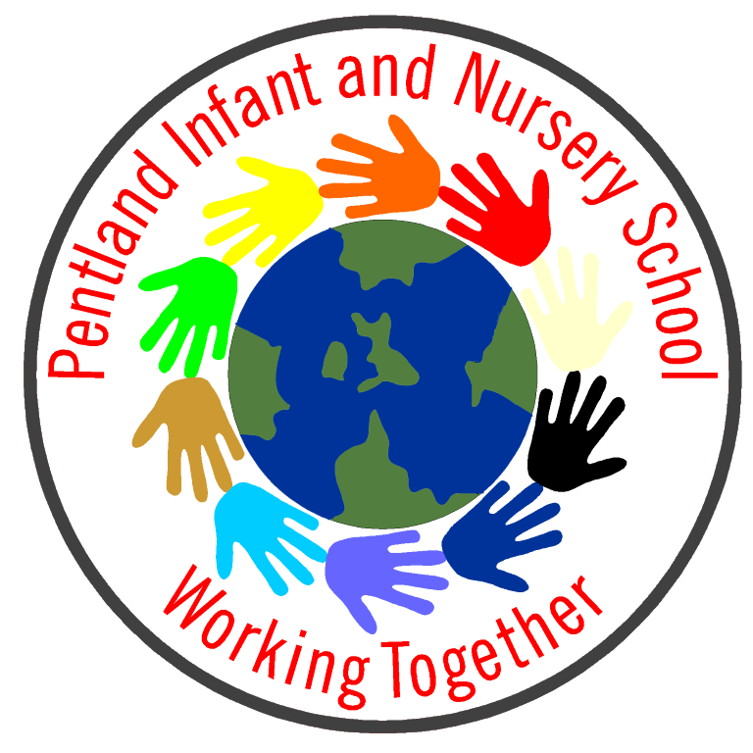
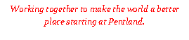

22/11/23

Dear Parents/ Carers,

As part of the Kirklees Year of Music 2023, our Year 2s have been chosen to take part in an exciting Musical project with the Royal Opera House. We have been participating in a series of lessons in school,
learning songs from Mozart’s famous opera - The Magic Flute.

The project will finish with our children attending a celebratory performance at the Huddersfield Town Hall on Wednesday 6th December. The trip will be free and coaches will be provided to take us to the Town Hall and back. The experience will take place within the school day.

At this event, we will be meeting opera singers who perform at the Royal Opera House in London and performing together the songs we have learnt from the Opera. I hope you agree that this is a fantastic opportunity for our children to participate in a perhaps new and exciting experience.

We will let you know in due course about timings. Please do come and see us if you have any questions.

Best wishes,

Mrs Rushby, Mrs De’Ath and Miss Child

……………………………………………………………………………………………………………………………………….

Name of child……………………………………………….Class…………

I would like my child to go on the trip ¨

I would not like my child to go on the trip o

Name of Parent ……………………….

Parent signature…………………………… Date……………………

