
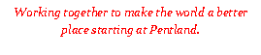

11th December 2023

Dear Parents and Carers,

As part of our transition work with Headfield Junior School, our Year Two pupils have been invited to watch a dress rehearsal of the Year Three winter performance. We will be visiting the school during the morning of Tuesday 19th December 2023.

On the day of the performance, Year Two pupils should arrive at Pentland School at the usual time. Once the children are registered, we will all walk to Headfield Junior School. Please can you make sure that your child is wearing comfortable, sensible shoes and a warm coat.

If you have any questions, please speak to the class teacher.

Yours sincerely,

The Year Two Team

